Multiplicative Numerals

✅ Definition:
# Source: AI Source: Provided by: [Data Path: Persons Table -> ID Column: 1, Name_En Column: Motasem Essam] -> From: [Chatgpt (GPT-4-turbo)] on [7/28/2025]
Multiplicative numerals express how many times something happens, exists, or is multiplied.
They answer the question: “How many times?” or “In what multiples?”

🧩 Examples of Multiplicative Numerals:
# Source: AI Source: Provided by: [Data Path: Persons Table -> ID Column: 1, Name_En Column: Motasem Essam] -> From: [Chatgpt (GPT-4-turbo)] on [7/28/2025]
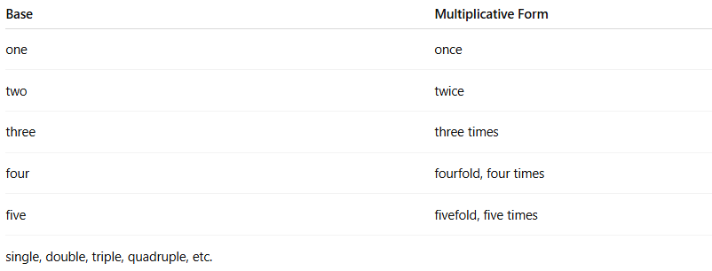
Base | Multiplicative Form
one | once
two | twice
three | three times
four | fourfold, four times
five | fivefold, five times
single, double, triple, quadruple, etc.

✏️ Examples in Sentences:
# Source: AI Source: Provided by: [Data Path: Persons Table -> ID Column: 1, Name_En Column: Motasem Essam] -> From: [Chatgpt (GPT-4-turbo)] on [7/28/2025]
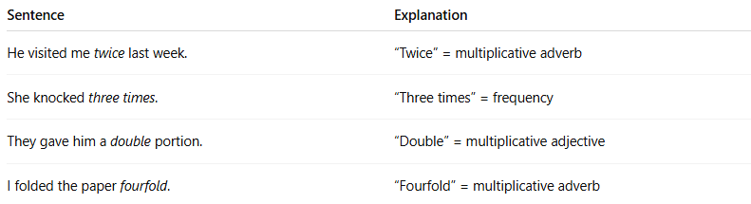
Sentence | Explanation
He visited me twice last week. | “Twice” = multiplicative adverb
She knocked three times. | “Three times” = frequency
They gave him a double portion. | “Double” = multiplicative adjective
I folded the paper fourfold. | “Fourfold” = multiplicative adverb

📌 Grammatical Functions:
# Source: AI Source: Provided by: [Data Path: Persons Table -> ID Column: 1, Name_En Column: Motasem Essam] -> From: [Chatgpt (GPT-4-turbo)] on [7/28/2025]
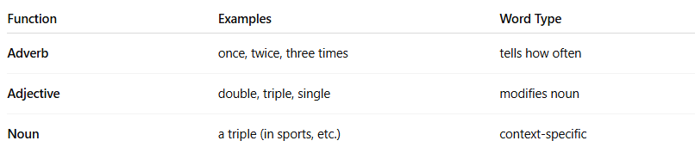
Function | Examples | Word Type
Adverb | once, twice, three times | tells how often
Adjective | double, triple, single | modifies noun
Noun | a triple (in sports, etc.) | context-specific

🔍 Properties of Multiplicative Numerals:
# Source: AI Source: Provided by: [Data Path: Persons Table -> ID Column: 1, Name_En Column: Motasem Essam] -> From: [Chatgpt (GPT-4-turbo)] on [7/28/2025]
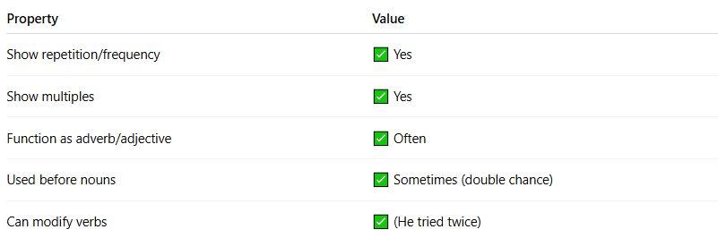
Property | Value
Show repetition/frequency | ✅ Yes
Show multiples | ✅ Yes
Function as adverb/adjective | ✅ Often
Used before nouns | ✅ Sometimes (double chance)
Can modify verbs | ✅ (He tried twice)

⚠️ Note:
# Source: AI Source: Provided by: [Data Path: Persons Table -> ID Column: 1, Name_En Column: Motasem Essam] -> From: [Chatgpt (GPT-4-turbo)] on [7/28/2025]
- Multiplicative ≠ Cardinal:
  - Three = how many
  - Three times = how many times an action happened
- Multiplicative ≠ Ordinal:
  - Third = position
  - Threefold = multiplied or expanded amount

🧠 Summary:
# Source: AI Source: Provided by: [Data Path: Persons Table -> ID Column: 1, Name_En Column: Motasem Essam] -> From: [Chatgpt (GPT-4-turbo)] on [7/28/2025]
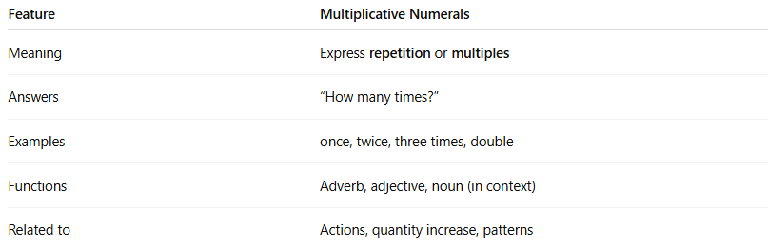

Feature | Multiplicative Numerals
Meaning | Express repetition or multiples
Answers | “How many times?”
Examples | once, twice, three times, double
Functions | Adverb, adjective, noun (in context)
Related to | Actions, quantity increase, patterns

